**Deploy Maven based war file to Tomcat example**

In this example, we will show you how to use the Apache Tomcat Maven plugin, in order to package and deploy a war file to Apache Tomcat.

1. **Create a user in Apache Tomcat**

First, we must create a user with administrator rights for the Apache Tomcat. Using the command prompt (Windows), navigate to the folder where the Apache Tomcat is installed. Then, navigate to the folder called conf and add the following code snippet to the tomcat-users.xml file, inside the <tomcat-users> tag:

<**role** rolename="manager"/>

<**role** rolename="admin"/>

<**role** rolename="manager-gui"/>

<**role** rolename="manager-script"/>

<**user** username="admin" password="admin" roles="admin, manager, manager-gui, manager-script"/>

We have now successfully created a new user, called admin.

1. **Create a user in Apache Maven**

Using the command prompt (Windows), navigate to the folder where the Apache Maven is installed. Recall that the MAVEN_HOME environment variable points to the home folder of Maven. Then, navigate to the folder called conf and add the following code snippet to the settings.xml file, inside the servers tag:

<**server**>

   <**id**>TomcatServer</**id**>

   <**username**>admin</**username**>

   <**password**>admin</**password**>

</**server**>

We created a user with the name Tomcat Server, along with its credentials.

1. **Add Apache Tomcat Maven plugin as a Dependency**

The next step is to declare the Apache Tomcat Maven plugin as a dependency to our project. Inside the pom.xml, we must add the following code snippet:

<**plugin**>

   <**groupId**>org.codehaus.mojo</**groupId**>

   <**artifactId**>tomcat-maven-plugin</**artifactId**>

   <**version**>1.1</**version**>

   <**configuration**>

      <**url**>[http://localhost:8085/manager/text](http://localhost:8080/manager/text)</**url**>

      <**server**>TomcatServer</**server**>

      <**path**>/leenaitwebapp</**path**>

   </**configuration**>

</**plugin**>

<username>admin1</username>

<password>admin1</password>

By using the above code snippet, we specify that our project must be deployed on [*http://localhost:8085/manager/text*](http://localhost:8085/manager/text)*,* in the path /leenaitwebapp, using the credentials of the Tomcat Server user.

A sample pom.xml file is shown below:

*pom.xml*:

<**project** xmlns="<http://maven.apache.org/POM/4.0.0>" xmlns:xsi="<http://www.w3.org/2001/XMLSchema-instance>"

xsi:schemaLocation="<http://maven.apache.org/POM/4.0.0><http://maven.apache.org/maven-v4_0_0.xsd>">

   <**modelVersion**>4.0.0</**modelVersion**>

   <**groupId**>com.javacodegeeks</**groupId**>

   <**artifactId**>SampleWebApplication</**artifactId**>

   <**packaging**>war</**packaging**>

   <**version**>1.0-SNAPSHOT</**version**>

   <**name**>SampleWebApplication Maven Webapp</**name**>

   <**url**>[http://maven.apache.org](http://maven.apache.org/)</**url**>

   <**dependencies**>

      <**dependency**>

         <**groupId**>junit</**groupId**>

         <**artifactId**>junit</**artifactId**>

         <**version**>4.11</**version**>

         <**scope**>test</**scope**>

      </**dependency**>

   </**dependencies**>

   <**build**>

      <**finalName**>SampleWebApplication</**finalName**>

      <**plugins**>

         <**plugin**>

            <**groupId**>org.apache.maven.plugins</**groupId**>

            <**artifactId**>maven-compiler-plugin</**artifactId**>

            <**version**>3.1</**version**>

            <**configuration**>

               <**source**>1.7</**source**>

               <**target**>1.7</**target**>

            </**configuration**>

         </**plugin**>

      <**plugin**>

         <**groupId**>org.codehaus.mojo</**groupId**>

         <**artifactId**>tomcat-maven-plugin</**artifactId**>

         <**version**>1.1</**version**>

         <**configuration**>

            <**url**>[http://localhost:8085/manager/text](http://localhost:8080/manager/text)</**url**>

            <**server**>TomcatServer</**server**>

            <**path**>/leenaitwebapp</**path**>

         </**configuration**>

      </**plugin**>

   </**plugins**>

   </**build**>

</**project**>

1. **Deploy the project to Apache Tomcat**

The first thing to do, before deploying our project, is start the Apache Tomcat. From the Windows command line, we execute the following command:

 C:\tomcat\bin\startup.bat

Now, using the command prompt (Windows), we navigate to the folder where our project is located. Then, we issue the command:

 $ mvn tomcat:deploy

 This command packages our project in a war file and deploys it to the Apache Tomcat. In order to verify that our installation is successful, we must go to the manager page of the Apache Tomcat and check that /leenaitwebapp actually exists:

[*http://localhost:8085/manager/html/*](http://localhost:8085/manager/html/)*:*

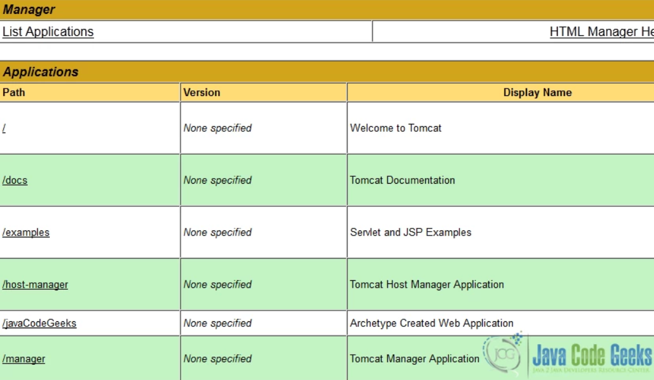

 Finally, if we want to deploy our project and the leenaitwebapp.war file already exists, we must issue the following command:

 $ mvn tomcat:redeploy

 Notice that the Apache Tomcat must already be**running**, before we issue this command.

**Note:** - Apache tomcat is a web container you cannot deploy a jar in tomcat server. If you created a web application then export your application as war file and put it in tomcat webapp directory, start the server and your war will be deployed